Joseph Silva Jr.

SNHU

CS 405: 5-2 Activity: Encryption Code

11/28/2021

**Code Debug Results**

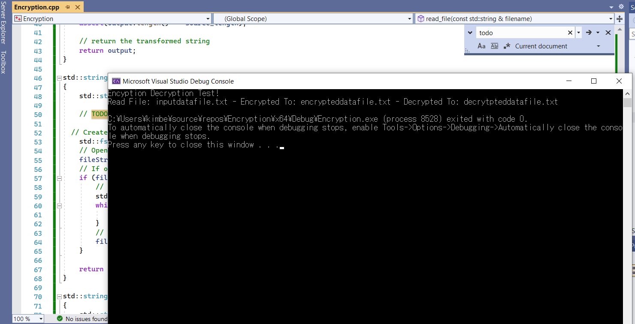

**Summary:**

The source data gets linked with a pass key. The data gets placed into an encryption text which is a file that is unreadable and scattered letters until it is decrypted with the pass key in order to change into readable data. During my law enforcement training, I reviewed many events for training when the dark web marketplace was used with encryption information and software, such as Kleopatra was used to decrypt the message with a pass key. I also know from training and personal use; encryptions are used when transferring cryptocurrency for purchases.